HC8256R/W
Binocular industrial temperature measurement camera
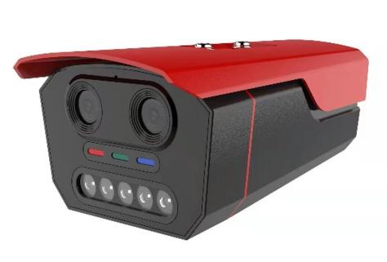

- Industrial grade thermal imaging temperature measurement module, thermal imaging 256x192 resolution
- Temperature measurement range: -20~+550 ℃, temperature measurement accuracy: ± 2 ℃ or ± 2% of reading
- Thermal imaging pixel size 12 μ m. Thermal sensitivity<50mk (@ 25 ℃)
- 4 million high-definition image sensors for better visibility into details
- Supports the proportional fusion of visible light and thermal imaging images, presenting exciting scenes 24 hours a day
- Supports multiple intelligent algorithms: smoke and fire detection, temperature detection, and other intelligent alarms
- Support multiple pseudo color modes: iron red, white hot, black hot, yellow blue pseudo color, and other modes
- Supports multiple temperature measurement area settings. If the set temperature threshold is exceeded, an alarm signal will be automatically pushed and associated with an alarm prompt tone
- Supporting standard ONVIF and GB28181 national standard protocols, excellent compatibility, and convenient access to backend platforms
- Supporting HTTP and MQTT push, providing protocol documents to connect with backend platforms

Technical specifications:
Thermal Module
Image Sensor | Vanadium oxide uncooled infrared focal plane detector
Max. Resolution | 256 × 192
Pixel Interval | 12 μm
Response Waveband | 8 μm to 14 μm
NETD | <50mk @25℃
Lens (Focal Length) | 4mm
Field of View | 56º±1º
Aperture | F1.0
Pseudo color mode | Iron red, white heat, black heat, yellow blue, etc
visible light
sensor type | 4.0MP 1/2.7' Progressive Scan CMOS
resolution ratio | 2560*1440
Minimum illumination | 0.001Lux
Visible lens focal length | 3.6mm
Day Night Conversion Mode | ICR infrared filterICR infrared filter
WDR | 79dB
Infrared irradiation distance | Up to 30 meters away
Image function
Dual light fusion | Support the fusion of visible light image information in thermal imaging channels, improving the details of thermal imaging channels
Intelligent information overlay | Support stacked heating imaging information in visible light channel images, such as temperature measurement rules and values
Intelligent detection | Supporting human form, smoking, making phone calls, fireworks, etc
Linkage alarm | Supports local alarm tone prompts and HTTP push
Temperature measurement function
Temperature abnormal function | Full screen temperature measurement, regional temperature measurement
Measuring range | : -20 ℃~550 ℃
Temperature measurement accuracy | Low temperature range ± 2 ℃ or high temperature range ± 2%
compression standard
Video | H265/H264
Audion | PCM/G711/G726
Image Resolution
Main Stream | 2560*144/2304*1296/1920*1080@25fps
Sub Stream | 640*480/480*360/240*240@25fps
General Protocol
network protocol | IPv4,HTTP,FTP,DNS,DDNS,NTP,RTSP,RTCP,RTP,TCP,UDP,DHCP,MQTT
interface protocol | ONVIF protocol, GB28181
Interface
Network interface | 1 RJ45 interface 10/100M adaptive Ethernet port
RS485 interface | 1ch
SD card storage | 1 built-in SD card slot
reset key | 1 reset key
General
power supply | DC 12V / POE
Working temperature and humidity | ‐20℃~50℃，<95% RH

