**IM50L35**

**5MP STARVIS HD Network Camera Module**

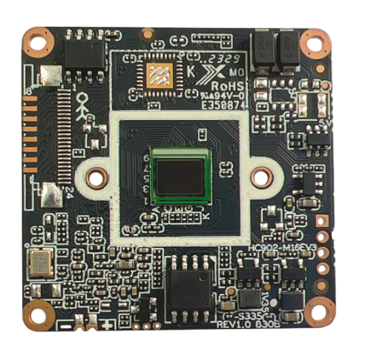

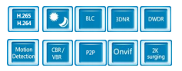

* 1/2.8”5.0MP Progressive Scan CMOS
* 5.0MP HD resolution
* Embedded Web Server, support Internet Explore monitoring, configuration, upgrade
* Support sub domain, easily to implement DHCP (ADSL dial-up)
* Support the P2P on Android, IOS
* Support ONVIF2.6
* Support Alarm pre-record
* Standard SDK(Linux,Windows) ，easily to be integrated with other digital systems

**Key Features：**

**Technical specifications:**

|  |  |
| --- | --- |
| **Image sensor** | |
| Sensor | 1/2.8” 5MP CMOS Sony IMX335 |
| Maximum resolution | 2592x1944@30fps |
| Minimum illumination | Color：0.05Lux B/W：0.01Lux |
| **Camera** | |
| AGC | Auto/Manual |
| S/N ratio | ≥50dB（AGC OFF） |
| Shutter speed | 1/2 - 1/20 ,000s，Slow shutter support |
| Wide dynamic range | Digital WDR≥73.7dB |
| Exposure mode | Auto/ Manual/shutter mode |
| White balance | Auto/ Manual /ATW/ Indoor/Outdoor/ lamp |
| Day & Night | External control（IR Cut Filter） |
| **Image resolution** | |
| Main stream | 2592*1944/1080P/720P@30fps  2560*1440/2480*1520/2304*1296/1080P/720P@25fps |
| Sub stream | D1/VGA/640*360/480*360/CIF@25fps； |
| **General protocol** |  |
| Network protocol | TCP/IP/HTTP/NTP/DHCP/SMTP/RTSP |
| ONVIF protocol | Standard ONVIF |
| **Network interface** |  |
| Wired | 1ch 10/100BaseT Ethernet，RJ45 interface |
| **Other** |  |
| Power supply | 12VDC |
| Size | 38x38mm |
| Operation temperature | -30°C ~85°C |
| Working humidity | ≤90%RH(non-condensing) |

|  |  |  |  |
| --- | --- | --- | --- |
| **Interface** | **Pin** | **Pin name** | **Functional parameter** |
| **J1** | 1 | 12VDC | DC power input, voltage range 5V-13.6V |
| 2 | Gnd | Signal ground |
| 3 | ETH_LED | Network indicator light interface |
| 4 | IR | Soft photosensitive infrared |
| 5 | Eth_TX- | Adaptive network interface, physically receiving/transmitting signals (differential -) |
| 6 | Eth_TX+ | Adaptive network interface, physically receiving/transmitting signals (difference +) |
| 7 | Eth_RX- | Adaptive network interface, physically receiving/transmitting signals (differential-) |
| 8 | Eth_RX+ | Adaptive network interface, physically receiving/transmitting signals (difference +) |
| 9 | WL | White light program control |
| 10 | CDS_IN | Hard light input |
| **J2** | 1 | IR-CUT＋ | IR-CUT signal + |
| 2 | IR-CUT－ | IR-CUT signal- |
| **J3** | 1 | Alarm_in1 | Alarm input 1 |
| 2 | Alarm_in2 | Alarm input 2 |
| 3 | GND | Signal ground |
| 4 | Alarm_out1 | Alarm relay output 1 |
| 5 | Alarm_out2 | Alarm relay output 2 |
| **J4** | 1 | Audio_In | Audio linear input interface, |
| 2 | Gnd | Signal ground |
| 3 | Audio_Out | Audio linear output interface |
| 4 | SYS_RST | Manual Reset |
| 5 | NC | / |
| **J5** | 1 | 3.3V | 3.3V power supply |
| 2 | USB_DM | data D- |
| 3 | USB_DP | data D+ |
| 4 | GND | Signal ground |

